TC-PM-008
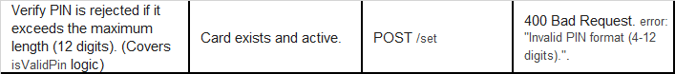
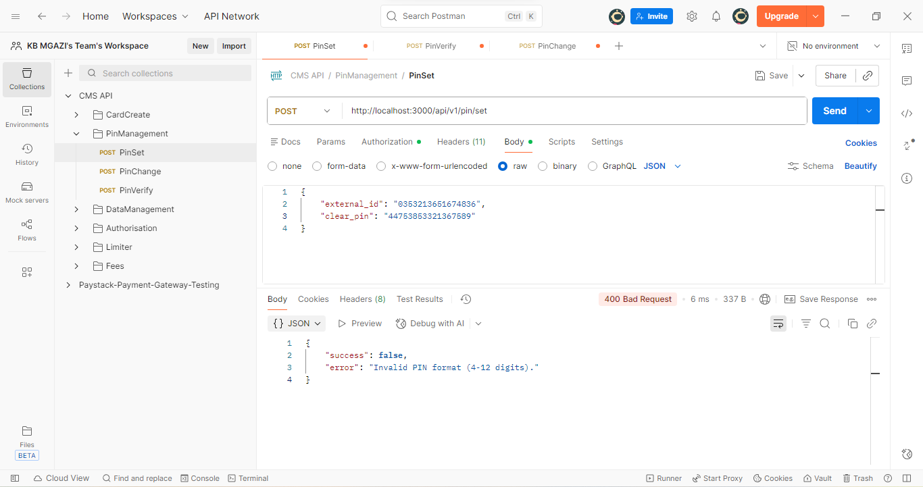
Request:
{
"external_id": "0353213651674836",
"clear_pin": "44753853321367589"
}
Response:
{
"success": false,
"error": "Invalid PIN format (4-12 digits)."
}

